|  |  |
| --- | --- |
| *Supplier*  *API Resource Specification* | |
| Document Title: | CES Supplier API Specification |

|  |  |
| --- | --- |
| **Information Security Classification:** | *Confidential* |
| **Status:** | *Draft* |
| **Version Number:** | *1.0* |
| **Date:** | Aug-27-2020 |
| **Originator:** | Ruban |
| **Supplier Approval:** |  |
| **Customer Approval:** |  |

Contents

1 Introduction 3

1.1 Document Purpose 3

1.2 References 3

2 Supplier API Overview 4

3 APIs Description 5

3.1 API Resource Specification - Get Task List 5

3.1.1 Description 5

3.1.2 Technical Definition 5

3.2 API Resource Specification - Post Planned, Baseline and Actual Exam Dates 9

3.2.1 Description 9

3.2.2 Technical Definition 9

3.3 API Resource Specification - Get Task List Agreement 12

3.3.1 Description 12

3.3.2 Technical Definition 12

3.4 API Resource Specification - Post Examination Data -Multipart Web API 14

3.4.1 Description 14

3.4.2 Technical Definition 14

3.5 API Resource Specification - Get Defect details 17

3.5.1 Description 17

3.5.2 Technical Definition 17

3.6 API Resource Specification - Get Recommendation details 21

3.6.1 Description 21

3.6.2 Technical Definition 21

4 Authentication and Authorization 24

5 Document History 25

6 Review History 25

**Error! Hyperlink reference not valid.Error! Hyperlink reference not valid.Error! Hyperlink reference not valid.Error! Hyperlink reference not valid.Error! Hyperlink reference not valid.Error! Hyperlink reference not valid.Error! Hyperlink reference not valid.Error! Hyperlink reference not valid.Error! Hyperlink reference not valid.Error! Hyperlink reference not valid.Error! Hyperlink reference not valid.Error! Hyperlink reference not valid.Error! Hyperlink reference not valid.Error! Hyperlink reference not valid.Error! Hyperlink reference not valid.Error! Hyperlink reference not valid.Error! Hyperlink reference not valid.Error! Hyperlink reference not valid.Error! Hyperlink reference not valid.Error! Hyperlink reference not valid.Error! Hyperlink reference not valid.Error! Hyperlink reference not valid.Error! Hyperlink reference not valid.Error! Hyperlink reference not valid.Error! Hyperlink reference not valid.Error! Hyperlink reference not valid.Error! Hyperlink reference not valid.Error! Hyperlink reference not valid.Error! Hyperlink reference not valid.Error! Hyperlink reference not valid.Error! Hyperlink reference not valid.Error! Hyperlink reference not valid.Error! Hyperlink reference not valid.Error! Hyperlink reference not valid.Error! Hyperlink reference not valid.Error! Hyperlink reference not valid.Error! Hyperlink reference not valid.Error! Hyperlink reference not valid.Error! Hyperlink reference not valid.Error! Hyperlink reference not valid.Error! Hyperlink reference not valid.Error! Hyperlink reference not valid.Error! Hyperlink reference not valid.Error! Hyperlink reference not valid.Error! Hyperlink reference not valid.Error! Hyperlink reference not valid.**

# Introduction

## Document Purpose

This document defines API resources between the Network Rail CES (CEFA Enabling Solution) solution and CEFA Supplier systems. The definition includes methods, paths, response format, request/response.

This document will form the design specification for the API to be initially developed.

## References

|  |  |  |
| --- | --- | --- |
| S.N0 | Documentation | Share point Link |
| 1 | ICD |  |
| 2 | DSD |  |

# Supplier API Overview

As part of the Civil Examination Framework Agreement (CEFA), Network Rail shall develop APIs (Application Programming Interface) to exchange examination data with the CEFA suppliers to facilitate the examination process for the Structures Assets.

To exchange exam data with NR, the CEFA suppliers will have the options to:

1. Access directly the CEFA Enabling Solution (CES), a web-based tool, or
2. Use APIs to exchange examination related information: It is envisaged that the Examining Organisations (suppliers) may privilege the exclusive use of their own system interfaces. In this case suppliers can use the APIs to receive from NR and send to NR the examination related information.

While using the APIs, the suppliers have options to

1. integrate the APIs with their existing systems or
2. use browser extensions to get and post data.

The below table lists the scenarios for data exchange between NR & the Examining Organisations (supplier):



|  |  |  |  |  |
| --- | --- | --- | --- | --- |
| **No** | **APIs Name** | **Publisher** | **Receiver** | **Trigger** |
|  | Get Task List | NR | Supplier | CEFA PM submits task list in CES |
|  | Post Planned, Baseline and Actual Exam Dates | Supplier | NR | Supplier Planner submits baselined, post planned or actual dates |
|  | Get Task List Agreement | NR | Supplier | AE confirms the planned dates, submitted by the supplier, in CES |
|  | Post Examination Data | Supplier | NR | To post exam data files |
|  | Get Defect details | NR | Supplier | Latest update in defect tracker |
|  | Get Recommendation details | NR | Supplier | Latest update in recommendations review |

# APIs Description

## API Resource Specification - Get Task List

### Description

|  |  |
| --- | --- |
| API Name | GetTaskListForSupplier |
| Resource Name | Task List |
| Publisher | Network Rail |
| Subscriber | Supplier |
| Peak Throughput | Max number of output records will be based on the Azure Service Limitation. Web APIs will implement paging to overcome any limitations |
| Granularity | Task list contains route specifics task for corresponding suppliers Lowest granularity in task list is record at examination level |
| Additional notes |  |

### Technical Definition

#### Access

|  |  |
| --- | --- |
| Path  (API/Version/Resource) | / Supplier/GetTaskListForSupplier |
| Verb | GET |
| Scope | Task List data |
| Response Format | JSON |

#### Message Specification

|  |  |  |  |
| --- | --- | --- | --- |
| **Name** | **Sample Values** | **Value Data type** | **Length** |
| Route |  | VARCHAR | 64 |
| ELR |  | VARCHAR | 4 |
| AREA |  | VARCHAR | 64 |
| REGION |  | VARCHAR | 64 |
| Start Mileage |  | DECIMAL | 5 |
| Start Yard |  | DECIMAL | 5 |
| End Mileage |  | DECIMAL | 5 |
| End Yard |  | DECIMAL | 5 |
| Railway ID |  | VARCHAR | 64 |
| Asset description |  | VARCHAR | 128 |
| Asset Group |  | VARCHAR | 64 |
| Asset Type |  | VARCHAR | 64 |
| AssetGuid |  | VARCHAR | 32 |
| Exam Request Status | Planned (CES), Requested (CES), Scheduled (CES), In Progress (CES), Completed (CARRS), Cancelled (CARRS) | VARCHAR | 50 |
| Exam Report Status | Received (CES), Allocated (CARRS), Evaluation Ready for signoff (CARRS), Rejected (CARRS), Signed off (CARRS), Rejected following audit (CARRS) | DECIMAL | 50 |
| Examination Type |  | VARCHAR | 32 |
| Exam ID |  | DECIMAL | 18 |
| Compliance Date |  | DATE |  |
| Due Date |  | DATE |  |
| On site Pre-compliance tolerance date |  | DATE |  |
| On site Post- compliance tolerance date |  | DATE |  |
| Baseline Planned Date | Populated by initial plan date submitted by supplier; cannot change based on new plan date. Blank if no planned dates; | DATE |  |
| Planned date | Populated by initial plan date submitted by supplier | DATE |  |
| Exam Date |  | DATE |  |
| Submission date |  | DATE |  |
| Signed off |  | VARCHAR | 64 |
| Exam Status |  | VARCHAR | 64 |
| CR ID | Populated only the Exam is CR | VARCHAR | 64 |
| Combined exams | Exam IDs of Combined Exams | VARCHAR | 1000 |
| Possession Critical | Yes/No | BOOLEAN |  |
| Specific Exam Requirement |  | VARCHAR |  |
| NR Internal Notes |  | VARCHAR |  |
| Comments to SEC(Supplier) |  | VARCHAR |  |

#### Sample Request and Response

|  |
| --- |
| **Request** |
| {  "supplierid": “Amey Rail”  } |
| **Response** |
| {  "success": “true”,  "message": "Task Details",  "data": {  {  "route":"Anglia",  "elr":"OWW ",  "start_mileage":"140",  “area”:”test”,  “region”:”test”,  "start_yard":"test",  "end_mileage":"test",  "end_yard":"test",  "railway_id":"1400727",  "asset_description":"CABINET Downside",  "asset_group":"B",  "asset_type":"C",  "exam_request_status":" Completed",  "exam_report_status":" Evaluation Ready for signoff "??????????,  "examination_type":"Detailed",  "exam_id":"2268526",  "compliance_due_date":"2016-11-14",  "on_site_pre_compliance_tolerance_date":"2016-11-01",  "on_site_post_compliance_tolerance_date":"2016-11-27",  "baseline_planned_date":"2016-11-14" blank?????????,  "planned_date":"2016-11-14" blank????????????,  “exam_date”:”2016-11-14” too early???????????,  “submission_date”:”2020-04-30” too early???????????,  “signed_off”:”2020-04-30” too early???????????,  “exam_status”:” Completed” too early???????????,  "crid":"test",  "combined_exams":"test",  "possession_critical":"test",  "scope":"test",  "comments":"test",  }  }  } |
|  |

## API Resource Specification - Post Planned, Baseline and Actual Exam Dates

### Description

|  |  |
| --- | --- |
| API Name | UploadTaskListWithPlannedDates |
| Resource Name | Task List |
| Publisher | Network Rail |
| Subscriber | Supplier |
| Peak Throughput | Max number of output records will be based on the Azure Service Limitation. Web APIs will implement paging to overcome any limitations |
| Granularity | Task list contains route specifics task for corresponding suppliers Lowest granularity in task list is record at examination level |
| Additional notes |  |

### Technical Definition

#### Access

|  |  |
| --- | --- |
| Path  (API/Version/Resource) | /Supplier/Tasklist/ |
| Verb | POST |
| Scope | Task List data |
| Response Format | JSON |

#### Message Specification

|  |  |  |  |  |
| --- | --- | --- | --- | --- |
| **Name** | **Sample Values** | **Mandatory** | **Value Data type** | **Length** |
| Route |  | Y | VARCHAR | 64 |
| ELR |  | Y | VARCHAR | 4 |
| Start Mileage |  | Y | DECIMAL | 5 |
| AREA |  | Y | VARCHAR | 64 |
| REGION |  | Y | VARCHAR | 64 |
| Start Yard |  | Y | DECIMAL | 5 |
| End Mileage |  |  | DECIMAL | 5 |
| End Yard |  |  | DECIMAL | 5 |
| Railway ID |  | Y | VARCHAR | 64 |
| Asset description |  | Y | VARCHAR | 128 |
| Asset Group |  | Y | VARCHAR | 64 |
| Asset Type |  | Y | VARCHAR | 64 |
| AssetGuid |  | Y | VARCHAR | 32 |
| Exam Request Status | Planned (CES), Requested (CES), Scheduled (CES), In Progress (CES), Completed (CARRS), Cancelled (CARRS) |  | VARCHAR | 50 |
| Exam Report Status | Received (CES), Allocated (CARRS), Evaluation Ready for signoff (CARRS), Rejected (CARRS), Signed off (CARRS), Rejected following audit (CARRS) |  | VARCHAR | 50 |
| Examination Type |  |  | VARCHAR | 32 |
| Exam ID |  |  | DECIMAL | 18 |
| Baseline Planned Date | Populated by initial plan date submitted by supplier |  | DATE |  |
| Planned date | Date to be provided by the supplier |  | DATE |  |
| Actual date |  |  | DATE |  |

#### Sample Request and Response

|  |
| --- |
| **Request** |
| {  {  "route":"Anglia",  "elr":"OWW",  "start_mileage":"140",  “area”:”test”,  “region”:”test”,  "start_yard":"test",  "end_mileage":"test",  "end_yard":"test",  "railway_id":"1400727",  "asset_description":"CABINET Downside",  "asset_group":"B",  "asset_type":"C",  "exam_request_status ":"Completed",  “exam_report_status “:”test”,  "examination_type":"Detailed",  "exam_id":" 2268526 ",  "baseline_planned_date":" 2016-11-14 ",  “planned_date”:”2016-11-14”,  "actual_date ":" 2016-11-14 "  }  } |
| **Response** |
| {  "success": “true”,  "message": "Planned date Submitted Successfully",  "data": { }  } |
|  |















## API Resource Specification - Get Task List Agreement

### Description

|  |  |
| --- | --- |
| API Name | ApproveSuppliersBaselinePlan |
| Resource Name | Baselineplan |
| Publisher | Network Rail |
| Subscriber | Supplier |
| Peak Throughput | Web APIs will implement paging to overcome any service limitations |
| Granularity | Task list contains route specifics task for corresponding suppliers Lowest granularity in task list is record at examination level |
| Additional notes |  |

### Technical Definition

#### Access

|  |  |
| --- | --- |
| Path  (API/Version/Resource) | /Supplier/Baselineplan |
| Verb | POST |
| Scope | Baseline plan data |
| Response Format | JSON |

#### Message Specification

|  |  |  |  |  |
| --- | --- | --- | --- | --- |
| **Name** | **Sample Values** | **Mandatory** | **Value Data type** | **Length** |
| Route |  | Y | VARCHAR | 64 |
| ELR |  | Y | VARCHAR | 4 |
| AREA |  | Y | VARCHAR | 64 |
| REGION |  | Y | VARCHAR | 64 |
| Start Mileage |  | Y | DECIMAL | 5 |
| Start Yard |  | Y | DECIMAL | 5 |
| End Mileage |  | N | DECIMAL | 5 |
| End Yard |  | Y | DECIMAL | 5 |
| Railway ID |  | Y | VARCHAR | 64 |
| Asset description |  | Y | VARCHAR | 128 |
| Asset Group |  | Y | VARCHAR | 64 |
| Asset Type |  | N | VARCHAR | 64 |
| AssetGuid |  | Y | VARCHAR | 32 |
| Exam Request Status | Planned (CES), Requested (CES), Scheduled (CES), In Progress (CES), Completed (CARRS), Cancelled (CARRS) | N | VARCHAR | 50 |
| Exam Report Status | Received (CES), Allocated (CARRS), Evaluation Ready for signoff (CARRS), Rejected (CARRS), Signed off (CARRS), Rejected following audit (CARRS) | N | VARCHAR | 50 |
| Examination Type |  | N | VARCHAR | 32 |
| Exam ID |  | N | DECIMAL | 18 |
| Baseline Planned Date | Populated by initial plan date submitted by supplier; cannot change based on new plan date. |  | DATE |  |
| Planned date | Populated by initial plan date submitted by supplier |  |  |  |

#### Sample Request and Response

|  |
| --- |
| **Request** |
| {  "route":"Anglia",  "elr":" OWW",  “area”:”test”,  “region”:”test”,  "start_mileage":"140",  "end_mileage":"727",  "start_yard":"test",  "end_yard":"test",  "railway_id":"1400727",  "asset_description":"CABINET Downside",  "asset_group":"B",  "asset_type":"C",  "exam_request_status ":"Completed",  "exam_report_status":" Evaluation Ready for signoff ",  "examination_type":"Detailed",  "exam_id":" 2268526 ",  "baseline_planned_date":" 2016-11-14 ",  "planned_date":" 2016-11-14 "  } |
| **Response** |
| {  "success": “true”,  "message": "Task List Agreement Submitted Successfully",  "data": { }  } |















## API Resource Specification - Post Examination Data -Multipart Web API

### Description

|  |  |
| --- | --- |
| API Name | SubmitExaminationData |
| Resource Name | Exam Data |
| Publisher | Network Rail |
| Subscriber | Supplier |
| Peak Throughput | Web APIs will implement paging to overcome any service limitations |
| Granularity | Service will allow multipart file to be posted to web API |
| Additional notes |  |

### Technical Definition

#### Access

|  |  |
| --- | --- |
| Path  (API/Version/Resource) | / Supplier/ExamData |
| Verb | POST |
| Scope | Exam data |
| Response Format | JSON |

* Web API Post Exam data will allow supplier to post bulk files of format (XML, PDF and Zip)
* Web API will publish the posted files to a blob storage for further processing
* It will be processed by Azure ADF pipeline on a schedule interval.
* Web API will acknowledge suppliers based on the files published to blob storage.
* In case of successful publish to blob storage it will acknowledge with successful response
* In case of exception or other issue the web API will acknowledge the request with internal server error or bad request.

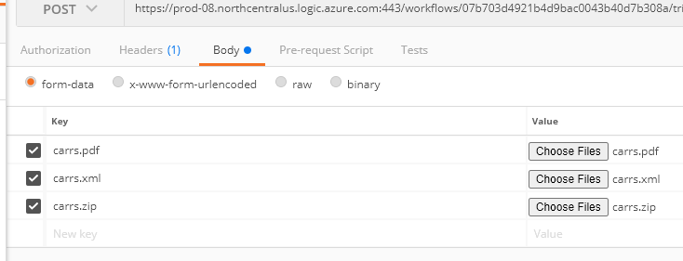

Message Specification



#### Sample Request and Response

|  |
| --- |
| **Request** |
| Multipart File of format PDF, XML, and/or Zip files |
| **Response** |
| <response>  <success status="true">  <message text="Uploaded successfully">  </response> |

## API Resource Specification - Get Defect details

### Description

|  |  |
| --- | --- |
| API Name | RetrieveDefectDetails |
| Resource Name | Defects |
| Publisher | Network Rail |
| Subscriber | Supplier |
| Peak Throughput | Web APIs will implement paging to overcome any service limitations |
| Granularity | Task list contains route specifics task for corresponding suppliers Lowest granularity in task list is record at examination level |
| Additional notes |  |

### Technical Definition

#### Access

|  |  |
| --- | --- |
| Path  (API/Version/Resource) | /Supplier/Defects |
| Verb | GET |
| Scope | Defect list data |
| Response Format | JSON |

#### Message Specification

|  |  |  |  |  |
| --- | --- | --- | --- | --- |
| **Name** | **Sample Values** | **Mandatory** | **Value Data type** | **Length** |
| Route |  | Y | VARCHAR | 64 |
| Area |  | Y | VARCHAR | 64 |
| Region |  | Y | VARCHAR | 64 |
| ELR |  | Y | VARCHAR | 12 |
| Start Mileage |  | Y | DECIMAL | 5 |
| End Mileage |  | N | DECIMAL | 5 |
| Asset Group |  | Y | VARCHAR | 5 |
| Asset Type |  | Y | VARCHAR | 5 |
| AssetGuid |  | Y | VARCHAR | 32 |
| Railway ID |  | Y | VARCHAR | 64 |
| Operational status |  | Y | VARCHAR | 64 |
| Material |  | N | VARCHAR | 64 |
| Owner |  | N | VARCHAR | 128 |
| #Open defects |  | N | DECIMAL | 18 |
| #All Defects |  | N | DECIMAL | 18 |
| Highest open defect score |  | N | VARCHAR | 10 |
| Defect ID |  |  | DECIMAL | 18 |
| Row Number( system generated) |  |  | DECIMAL | 18 |
| Description |  |  | VARCHAR | 256 |
| Location |  |  | VARCHAR | 250 |
| Location Major element |  |  | VARCHAR | 250 |
| Location Minor element |  |  | VARCHAR | 250 |
| Exam date |  |  | DATE |  |
| Exam ID |  |  | DECIMAL | 18 |
| Access Gained |  |  | VARCHAR | 5 |
| Exam type |  |  | VARCHAR | 32 |
| recommendation number |  |  | DECIMAL | 18 |
| Supplier risk score |  |  | VARCHAR | 10 |
| AE(S) risk score |  |  | VARCHAR | 10 |
| Access required |  |  | VARCHAR | 5 |
| Deterioration |  |  | VARCHAR | 64 |
| Repaired |  |  | VARCHAR | 5 |
| Flagged for closure |  |  | VARCHAR | 5 |
| Recommendation comments |  |  | VARCHAR | 1000 |
| User ID - Auto populated. |  |  | VARCHAR | 64 |

#### Sample Request and Response

|  |
| --- |
| **Request** |
| {  "supplierid": “test”  } |
| **Response** |
| {  "success": "true",  "message": "Defect Tracker list received",  "data": {    "route": "Anglia",  "area": "West Midlands & Chilterns",  “region”:”test”,  "elr": "OWW",  "start_mileage": "140",  "end_mileage": "727",  "asset_group": "B",  "asset_type": "C",  "railway_id": "1400727",  "operational_status": "test",  "material": " RBE - Aluminium ",  "owner": " Environment Agency ",  "open_defects": "5",  "all_defects": "8",  "highest_open_defect_score": " 20 ",  "defect_id": "121",  "row_number": "1",  "description": " Defective lighting",  "location": " Height signs ",  "location_major_element": "test",  "location_minor_element": "test",  "exam_date": "2016-01-20",  "exam_id": " 2268526 ",  "access_gained": "Y",  "exam_type": "Detailed",  "recommendation_number": "1",  "supplier_risk_score": "20",  "aerisk_score": "20",  "access_required": "N",  "deterioration": " Baseline ",  "repaired": "Y",  "flagged_for_closure": "1",  "recommendation_comments": " Clear the watercourse and remove the build up of silt",  "user_id": " Colin King"  }  } |
|  |

## API Resource Specification - Get Recommendation details

### Description

|  |  |
| --- | --- |
| API Name | RetrieveRecomendationDetails |
| Resource Name | Defect |
| Publisher | Network Rail |
| Subscriber | Supplier |
| Peak Throughput | Web APIs will implement paging to overcome any service limitations |
| Granularity | Task list contains route specifics task for corresponding suppliers Lowest granularity in task list is record at examination level |
| Additional notes |  |

### Technical Definition

#### Access

|  |  |
| --- | --- |
| Path  (API/Version/Resource) | /Supplier/Recommendations |
| Verb | GET |
| Scope | Defect data |
| Response Format | JSON |

#### Message Specification

|  |  |  |  |  |
| --- | --- | --- | --- | --- |
| **Name** | **Sample Values** | **Mandatory** | **Value Data type** | **Length** |
| Route |  |  | VARCHAR | 64 |
| Area |  |  | VARCHAR | 64 |
| ELR |  |  | VARCHAR | 4 |
| Start Mileage |  |  | DECIMAL | 5 |
| Start Yard |  |  | DECIMAL | 5 |
| Asset Group |  |  | VARCHAR | 64 |
| Asset Type |  |  | VARCHAR | 64 |
| AssetGuid |  |  | VARCHAR | 32 |
| Railway ID |  |  | VARCHAR | 64 |
| Description |  |  | VARCHAR | 128 |
| Exam ID |  |  | DECIMAL | 18 |
| Exam Type |  |  | VARCHAR | 32 |
| Supplier |  |  | VARCHAR | 64 |
| Actual Exam Date |  |  | DATE |  |
| Signed off By |  |  | VARCHAR | 64 |
| Notes |  |  | VARCHAR | 4000 |
| Recommendation No |  |  | DECIMAL | 18 |
| Recommendation Desc |  |  | VARCHAR | 1000 |
| Location |  |  | VARCHAR | 128 |
| Working Category |  |  | VARCHAR | 64 |
| Quantity |  |  | DECIMAL | 18,2 |
| Units |  |  | VARCHAR | 32 |
| Est Cost K |  |  | DECIMAL | 18,2 |
| Risk Score Status |  |  | VARCHAR |  |
| Feedback |  |  | VARCHAR |  |

#### Sample Request and Response

|  |
| --- |
| **Request** |
|  |
| **Response** |
| {  "success": “true”,  "message": "Defect Tracker list received",  "data": {  {  "route":"Anglia",  "area":" West Midlands & Chilterns ",  "elr":" OWW",  "start_mileage":"140",  "start_yard":"727",  "asset_group":"B",  "asset_type":"C",  "railway_id":"1400727",  "description":" Defective lighting ",  "exam_id":" 2268526 ",  "exam_type":"Detailed",  "supplier":"AMY",  "actual_exam_date":"2016-01-20",  "signed_off_by":"Colin King",  "notes":"Baseline",  "recommendation_no":"140",  "recommendation_desc":" Clear the watercourse and remove the build up of silt ",  "location":"Height signs",  "working_category":"Detailed",  "quantity":"121",  "units":"1",  "est_cost_k":"20",  "risk_score_status":"test",  "feedback":" Clear the watercourse and remove the build up of silt "  }  }  } |

# Authentication and Authorization

High level design

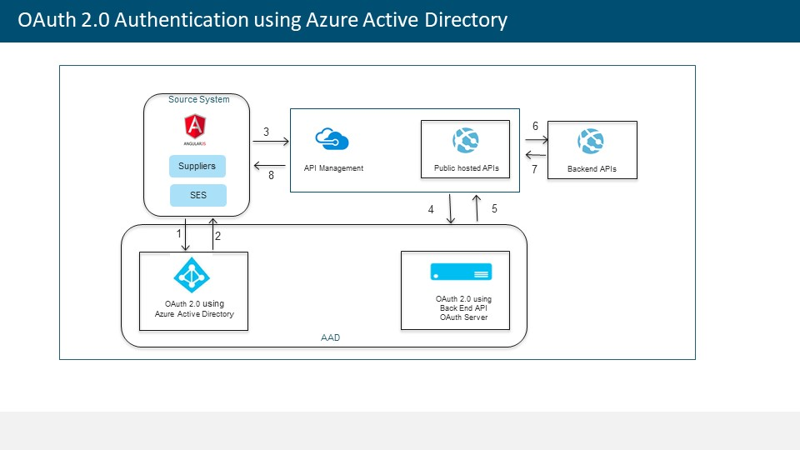

Steps:

1. User (CES UI/SES/Suppliers) will submit valid service principles to AAD URI for Authentication token.
2. On successful authentication- AAD will return valid authorization token.
3. User will make a request to APIs using valid authorization token received at step 2.
4. API request will be validated (token validation) against the OAuth Server.
5. Based on successful validation request will be routed to backend API.
6. Connectivity to backend service will be maintained.
7. Response from the Backend APIs will route to API.
8. Response from the Backend APIs will route to User.

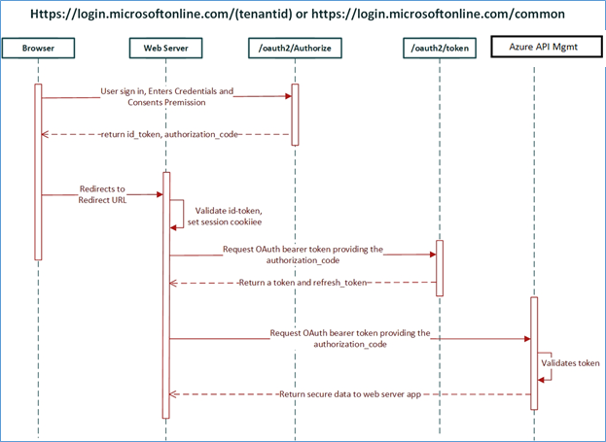

# Document History

|  |  |  |  |
| --- | --- | --- | --- |
| **Version** | **Date** | **Changed By** | **Description of Change** |
| 0.1 | 26/08/2020 | Ruban chandar | Initial draft |
| 1.0 | 27/08/2020 | Kumarapathy | Added sample data and data type |
|  |  |  |  |
|  |  |  |  |
|  |  |  |  |
|  |  |  |  |

# Review History

|  |  |  |  |
| --- | --- | --- | --- |
| **Date** | **Specification Version** | **Reviewers** | **Outstanding comments?** |
|  |  |  |  |
|  |  |  |  |
|  |  |  |  |
|  |  |  |  |